**G908GU: 4G Cat.1+BLE+GPS, Sound and light Alarm**

**Product Drscription:**

The Tracker is heavy, sturdy, and has an extra-large battery. It is suitable for a variety of applications such as asset and device location tracking that require ultra-long standby and reliable scenarios. For example: all kinds of non-powered vehicles (Air China), airport and supermarket trolleys (Wuhan Tianhe Airport), outdoor work construction vehicles, valuable assets, etc.

1. Ultra-low power consumption, ultra-long standby

a) The system architecture is a low-power Cortex M4 main control processor + ultra-low-power LoRa module. Make sure that the system bottom

current < 0.1mA

b) Ultra-low power 4G Cat.1 bis module (Cortex M3 architecture, memory 4M+2M, small memory lower low power consumption),

Cat.1 bis module base current<10uA

c) 3X1650 Industry Chargable Battery 6000mAh(2000mAhX3 capacity battery), super long standby and use time. Magetic Charging

d) Support breakpoint resumable transmission (in the position where there is no signal, the positioning and step counting data will be saved, and

wait for the signal to be transmitted centrally)

e) The positioner is easy to operate (the charger is unplugged and automatically turned on)

f) IP67 waterproof design, high strength shell

2. Indoor and outdoor fusion positioning, high-precision positioning:

a) Support GPS/Beidou + wifi + base station indoor and outdoor positioning,

b） Built-in motion sensor to realize step counting and detection of movement, if there is no movement, it will enter the ultra-long standby mode

c) Built-in Bluetooth 5.1 with low energy consumption, support scanning Bluetooth indoor positioning, positioning accuracy 3-5 meters. Support

Bluetooth AOA high-precision positioning.

d) Support UWB high-precision positioning: Support UWB beacon mode without wiring. It also supports open UWB chip SDK for easy access to

third-party UWB systems.

e) Support Bluetooth ranging (accuracy 3-5 meters), optional sound and light alarm

3. Hardware configuration:

a) UWB high-precision ranging version G908GU; Cooperate with watches, helmet locators and badges to achieve ranging alarms

b) Optional: external audible and visual alarm (buzzer and bright LED light, 80 or 110 dB), which can be used for forklifts, hazardous area alarms

c) Optional: strong magnetic adsorption (45 kg/piece), up to 4 magnets can be installed.

Available version

G908G: 4G Cat.1+BLE5.1, GPS/Beidou+Wifi+Accelerometer, 6000mAh Battery, Adsorption Charging, 2 Buttons + Waterproof (Optional sound and light

alarm)

G908GU: UWB+4G Cat.1+BLE5.1, GPS/Beidou+Wifi+Accelerometer, 6000mAh Battery, Adsorption Charging, 2 Buttons + Waterproof (Optional sound and

light alarm)

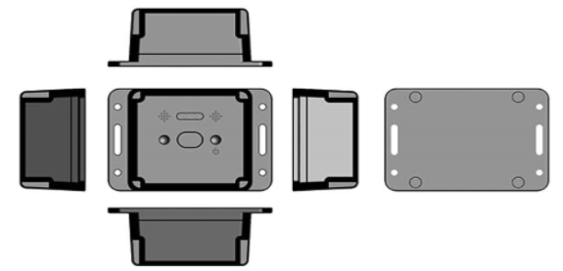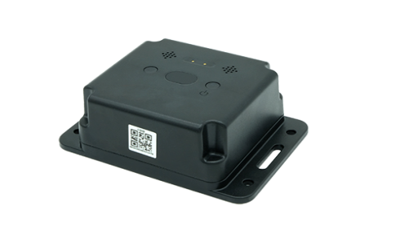

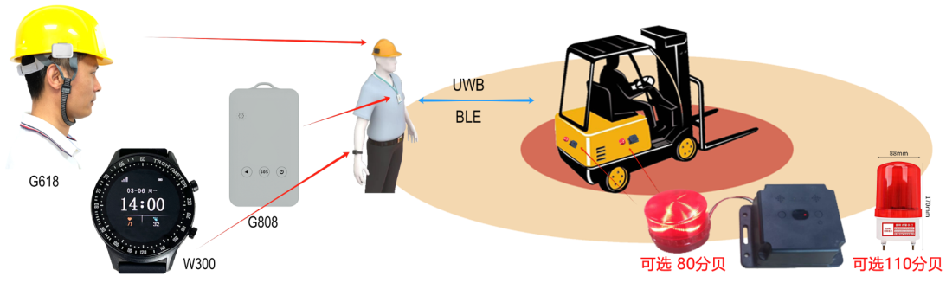

**Product specification**

|  |  |  |
| --- | --- | --- |
| **Category** | **Item** | **Description** |
| Appearance | Size/Weight | 125 x 85 x 50mm / 360g |
| Color | Black |
| Material | PC + ABS |
| Wearing method: | Locking screws or 3M adhesive stickers, or magnetic suction |
| Plarform | MCU | BLE5.1 Cortex-M4 SOC（for OTA, Broadcast / Scaning IBeacon, etc） |
| Memory | 64KB SRAM + 1MB Flash |
| G908G | Network | 4G Cat.1 |
| Band | LTE-FDD：B1/3/5/8; LTE-TDD: B34/B38/B39/B40/B41 |
| SIM Card | Nano SIM Inside |
| G908L | Network | LoRaWAN or LoRa |
| Band | 433MH： Public frequency band and is suitable for most parts of the world  470~510MHz： For China Mainland，CN470  862~870MHz： For Europe，EU868  902~928MHz： For America, Australia, Asia, Korea, Japan and other regions  US915 / AU915 / AS923/ KR920 |
| G908GU  G908LU | Network | 4G( or W200PLU-LoRa/LoRaWAN)+UWB(MK8000+GPS+BLE5.1 |
| UWB Band | CH5, CH9 （UWB芯片：MK8000） |
| Cooperation model | 1. Default, it supports the UWB ranging alarm G908GU (to achieve ranging alarm) or UWB   beacon UB01 (to achieve UBeacon positioning).   1. Open MK8000-UWB SOC chip SDK, which is convenient for customers to develop MK8000   UWB air protocol and connect with third-party UWB base stations or UWB beacons. (MK8000 and device master MCU serial port communication) |
| Location  And  Positioning | Location | GPS/Glonass/Galileo + Wifi + LBS + BLE |
| Satellite accuracy | 5-20 meters in an open Sky (satellite positioning at least the device can correspond to 1/4 of the unshielded sky |
| Wifi accuracy | Depending on the density of the surrounding WiFi, generally 10-50 meters |
| BLE accuracy | Depending on the deployment density of ibeacons, point, plane, and stereo positioning can be achieved  (If the beacon deployment density is 6-8 meters, the accuracy is 1-3 meters;  if it cooperates with the AOA Bluetooth gateway, it can reach the level of 1 meter) |
| Wear detection | Built-in high-precision acceleration sensor, enter ultra-low power consumption mode without moving (think not wearing it) |
| UI Interface | LED | 2 X LEDs |
| Keypad | 2 Keys |
| Electrical Features | Battery | Li-ion Battery，6000mAh / 3.7V / Charging time：8 Hours |
| Charging | Magnetic Charging Cable (standard); |
| Charger Adaptor | 5V / 1A （Optional） |
| Standby Time | Standby for more than 200 days;  normal use: more than 30-60 days (default positioning report every 10 minutes) |
| Environment  Features | Working Temp | -10°C ~ 60°C |
| storage temp. | -30°C ~ 80°C |
| Working humidity | -10% ~ 85% HR |
| Waterproof | IP67 waterproof |
| Functions | Electric Fence | The Platform supports circles, custom areas, and administrative areas;  the Mobile Application(IOS and Andriod Apps) supports circular fences |
| Historical Track | Support historical data query for more than 100 days |
| Alarm | SOS, Inside the fence, Outside the fence, Low Power, Power off, etc. |
| Platform | supports users to change the logo and name, hierarchical management, etc |
| Other Featues | Blind spot supplementary | Support blind spot supplementary report (positioning and health data will be saved in locations where there is no signal, waiting for a signal to be transmitted centrally) |
| G-Sensor | YES |
| Packaging | Stand Packaging | Neutral packaging：Tracker X1, Rope X1, Charger Cable X 1, User Manual X1, Platform / Apps User Manual X 1 |
| Optional | Charger Adaptor ; iBeacon OV02 / OV03 |