W200PL,W200PLU - LoRaWAN+BLE+GPS, Health Smart Watch
Product Overview
The watch is IP67 waterproof, intrinsically safe and explosion-proof, atmospheric, sturdy, and suitable for use in various scenarios. There are versions such as 4G Cat.1, NBIoT, LoRa, LoRaWAN, UWB and Single Bluetooth
1. Ultra-low power consumption, ultra-long standby
a) The system architecture is low-power Cortex M4 main control processor + ultra-low-power LoRaWAN Module. Make sure that the system bottom current < 0.1mA
b) c) Support LoRaWAN (gateways that can be adapted to all LoRaWAN); LoRa private protocol is also supported (with matching
indoor and outdoor LoRa gateways, DTUs)
c) 450mAh capacity battery, super long standby.
2. Indoor and outdoor fusion positioning, high-precision positioning:
a) Support GPS/Beidou/Glonass: indoor and outdoor positioning
b) The watch has built-in BLE 5.1 with low energy consumption, which supports scanning Bluetooth indoor positioning, with a positioning accuracy of 3-5 meters. Support BLE AOA high-precision positioning.
c) Support UWB high-precision positioning: Support UWB beacon mode without wiring. It also supports open UWB chip SDK for easy access to third-party UWB systems.
3. High-precision health sensor, real-time health detection and reporting
a) Goodix GH3011 high-precision sensor. Support blood oxygen, ambulatory heart rate, HRV, body temperature, blood pressure, and step counting health data to be measured and reported regularly.
b) Support mood, fatigue, stress, mood and other indicators and data analysis (third-party platforms need to be charged)
c) The bracelet has wear detection (the message of the bracelet is reported to the platform and APP when wearing and removing it), and it will enter the ultra-low power mode if it is not worn (standby for more than 30 days)
d) Has a high-altitude drop algorithm.
4. Other business functions:
a) The bracelet supports the background and APP to send messages, the bracelet vibrates and reminds, and the message can be broadcast by voice. Touch screen to confirm replies (dispatch business, order acceptance and rejection).
b) SOS one-key alarm, low power alarm, shutdown alarm, long-term inactive alarm, entry and exit fence alarm, health data exceedance, electronic fence, historical track query and other functions
c) The bracelet has a wear detection (the bracelet is worn and removed, and the message is reported to the platform and APP), and it will enter the ultra-low power mode if it is not worn (standby for more than 20 days)
d) Positioning and health data reporting frequency settings. Support resumable transmission (in a location where there is no signal, save the data, wait for the signal to be transmitted in a centralized manner)
e) Smart construction site application: widely used in Chinese mainland, Hong Kong, Taiwan and other overseas (Chinese and English, sedentary reminder, weather forecast issued, high-altitude fall alarm, people and vehicles approaching alarm, etc.) Where there is no signal, Bluetooth gateways are supported to report data, and there are also LoRa/LoRaWAN versions, UWB versions)
5. Hardware configuration:
a) 1.22 inch 240X210 dot matrix round IPS screen. Standard 22mm width strap, interchangeable strap (velcro, metal, leather, silicone, etc.)
b) The built-in Bluetooth Low Energy 5.1 of the bracelet can be connected to a variety of Bluetooth peripherals (transmitting the data of the peripherals to the bracelet to the background), or connecting to the mobile phone (or data terminal) to transmit positioning and health data to the mobile phone (data terminal).
c) Standard: 13.56MHz NFC tag in the strap
d) Optional: portable charging case (52X50X18cm can charge 32 watches)
e) For special use scenarios such as construction sites and coal mines, we also specially equip the watch with a tempered glass film to protect the screen from impact damage
f) Chinese mainland has a built-in 3-year IoT card by default. Hong Kong, Taiwan, Southeast Asia, the Middle East, Europe, Africa, America, etc. can be shipped with cards.
Comparison differences between W300P, W300 and W200PG:
 | W300P | W300 | W200P
Outlook | The length and width of the ID are the same,  the curvature of the back design is slightly different |  | Different ID
Size/Thickness | 47 X 56 X 14.2 mm | 47 X 56 X 13mm | 46 x 52 x 15mm
Battery | 760mAh | 580mAh | 450mAh
Weight | 52g（34g without Strap） | 51g | 49g
Display | 1.3 inch; 240X240 dots |  | 1.22 inch; 240X210 dots
Speaker | NO | YES | YES
Charger | small 2Pin Magnetic (same as B2315） | 2Pin Magnetic
Keypad | 2 side key micro protrusions | 2 side keys protruding | 2 side keys protruding
NFC Tag | NFC Tag under LCD | NFC Tag under LCD | Optional in Strap

Product configuration: (● Configuration; ○ Configuration none)
 | Mode | WifiLocation | RFID | Notes
W200PG | 4G Cat.1 | ● | Optional In the  Strap | 4G+GPS+BLE+Wifi Location
W200PGU | 4G+UWB | ● |  | UWB+4G+GPS+BLE+Wifi定位，
W200PL | LoRa/LoRaWAN | ○ |  | LoRa +GPS+BLE
W200PLU | LoRa+UWB | ○ |  | UWB+LoRa/LoRaWAN +GPS+BLE，
W200L | LoRaWAN | ○ |  | LoRa/LoRaWAN +GPS+BLE，no SPO2.
W200U | UWB+BLE | ○ |  | UWB+BLE
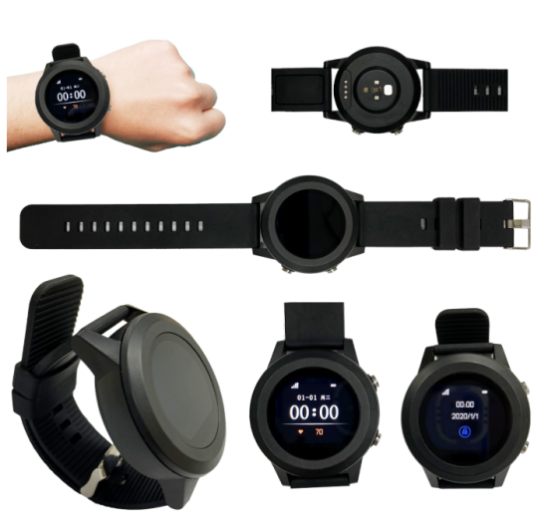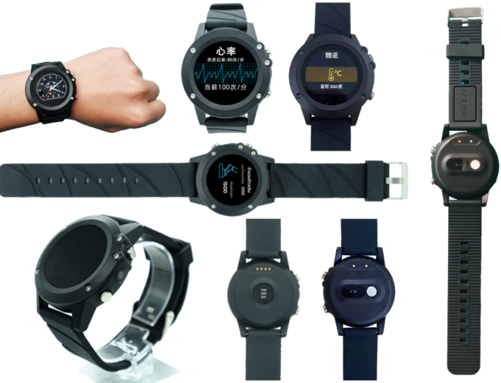
W200PL (touch screen, IP67 Waterproof ) W200L (no touch screen, front with 5 screws assembly-IPX5)
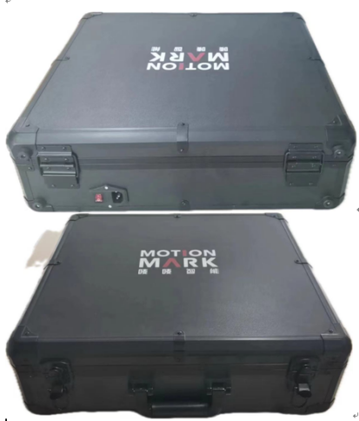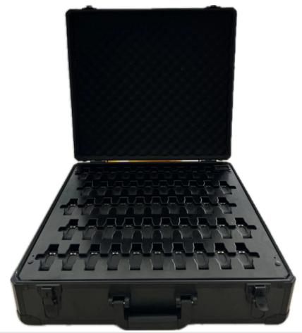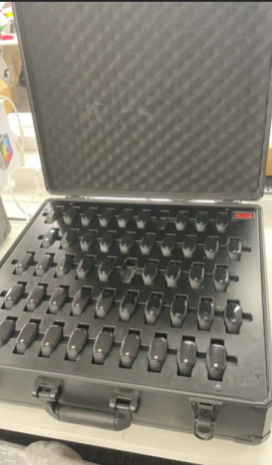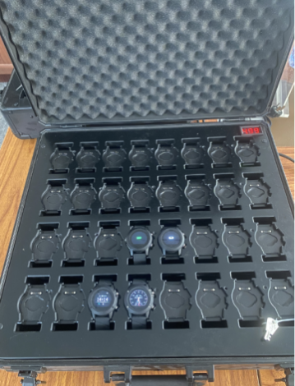
Optional: Portable Charging Case-(52X50X18cm can charge 32 watches, Logo can be customized)
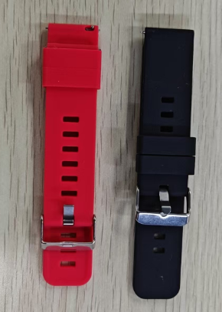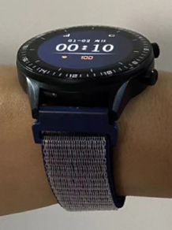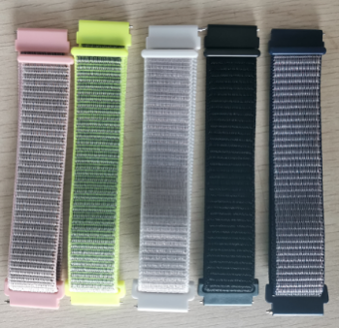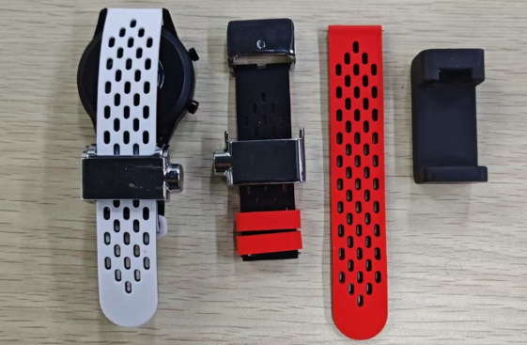
Optional: Red silicone strap; strap with RFID tag; Velcro strap (multiple colors); Magnetic tamper-evident strap (red and white, black inside)
Product Specifications:
Category | Item | Description
Appearance | Size/Weight | W200PL： 46 x 52 x 15 mm / 50g W200L： 46 x 52 x 14.5 mm / 39g
 | Color | Black body + default black band; Other color straps are available
 | Material | PC+ABS; Strap: Silicone
 | Strap | Standard: Black silicone strap; Standard 22mm strap  Optional: red silicone strap; strap with RFID tag; Velcro strap (multiple colors); metal  tamper-evident strap; Silicone tamper-evident strap.
Plarform | MCU | BLE5.1 (support online upgrade, Bluetooth broadcast, scan beacons, connect Bluetooth host)
 | Memory | 256KB SRAM + 5MB Flash
W200PG  4G Cat.1 | Network | 4G Cat.1
 | Band | FDD：B1/B3/B5/B8，TDD：B38/B39/B40/B41
 | SIM Card | Inside Nano SIM
W200PL  LoRaWAN  （LoRa） | Network | LoRaWAN
 | Band | 433MH： Public frequency band and is suitable for most parts of the world  470~510MHz： For China Mainland，CN470  862~870MHz： For Europe，EU868  902~928MHz： For America, Australia, Asia, Korea, Japan and other regions  US915 / AU915 / AS923/ KR920
W200PU | Network | UWB+BLE5.1
 | UWB Band | CH5, CH9 （UWB：DW3000）
 | Cooperation model | - Watch + UWB base station shipped together: It has been successfully docked, including many  UWB base stations and UWB beacons such as empty cycle  - Open UWB module (52832+DW3000) data, so that customers can develop DW3000 air  protocol based on 52832 and connect with third-party UWB base stations (52832 of UWB module and serial port communication of equipment main control MCU)
W200PLU | Network | 4G( or W200PLU-LoRa/LoRaWAN)+UWB(MK8000+GPS+BLE5.1
 | UWB Band | CH5, CH9 （UWB芯片：MK8000）
 | Cooperation model | - Default, it supports the UWB ranging alarm G908GU (to achieve ranging alarm) or UWB  beacon UB01 (to achieve UBeacon positioning).  - Open MK8000-UWB SOC chip SDK, which is convenient for customers to develop MK8000  UWB air protocol and connect with third-party UWB base stations or UWB beacons. (MK8000 and device master MCU serial port communication)
Location  And  Positioning | Location | GPS/GLONASS/Galileo + Wifi + LBS + BLE
 | Satellite accuracy | 5-20 meters in an open Sky (satellite positioning at least the device can correspond to 1/4 of the unshielded sky)
 | Wifi accuracy | Depending on the density of the surrounding WiFi, generally 10-50 meters
 | BLE accuracy | Depending on the deployment density of ibeacons, point, plane, and stereo positioning can be achieved  (If the beacon deployment density is 6-8 meters, the accuracy is 1-3 meters;  if it cooperates with the AOA Bluetooth gateway, it can reach the level of 1 meter)
 | Wear detection | Built-in high-precision acceleration sensor, enter ultra-low power consumption mode without moving (think not wearing it)
UI Interface | Display | 1.22inch 240 X210 dotsIPS TFT；W200PG-with Touchpanel
 | Keypad | 2 Side Keys
 | Speaker | 4G version:YES; LoRa Version: No
 | Vibrator | YES
Electrical Features | Battery | Li-ion Battery，450mAh / 3.7V / Charging time：2 Hours
 | Charging | Magnetic USB interface charging cable (standard)
 | Adaptor | 5V / 1A （Optional）
 | Standby Time | Standby for more than 10 days;  normal use: more than 3-4 days (default positioning report every 10 minutes)
Environment  Features | Working Temp | -10°C ~ 60°C
 | storage temp. | -30°C ~ 80°C
 | humidity | -10% ~ 85% HR
 | Waterproof | IPX7
 | Explosion-proof | Ex ib IIC T4 Gb (China explosion proof)
Functions | Electric Fence | The Platform supports circles, custom areas, and administrative areas;  the Mobile Application(IOS and Andriod Apps) supports circular fences
 | Historical Track | Support historical data query for more than 100 days
 | Alarm | SOS, Inside the fence, Outside the fence, Low Power, Power off, etc.
 | Platform | supports users to change the logo and name, hierarchical management, etc
Health  Features | Oxygen-SPO2 | PPG Reflective Blood Oxygen (Red + Infrared)
 | body temp. | High-precision temperature measurement module (temperature measurement accuracy is plus or minus 0.2 degrees)
 | heart rate | Dual-color mode + Goodix 3011 (3018) sensor, supporting high-precision dynamic heart rate
 | Blood pressure | Yes (converted by heart rate data, inaccurate, use with caution)
 | HRV(RRI) | Used in mood and psychology applications, etc. (support for third-party emotion, stress algorithms; or custom SDK extraction)
 | Step | Support (cleared at 0:00 every day, reported regularly)
 | Sleep | Support (support deep sleep, light sleep, and regular reporting of wakefulness)
Other Features | Blind spot supplementary | Support blind spot supplementary report (positioning and health data will be saved in locations where there is no signal, waiting for a signal to be transmitted centrally)
 | Health | Predometer, Sleep detection; HeartRate; Body Temperature. SPO2
 | G-Sensor | YES
 | gyroscope | Default No (Optional)
 | Compass | Default No (Optional)
 | Wear Detection | Support (wearing and removal have messages reported to the platform and APP)
 | Message | Support
 | RFID | Optional NFCTag Strap （RFID M1 Card）
Packaging | Stand Packaging | Neutral packaging：Wristband X1, Charger Cable X 1, User Manual X1, Platform / Apps User Manual X 1
 | Optional | RFID Tag ; Charger Adaptor ; iBeacon OV02 / OV03；Buckle Strap, Velcro Strap; Charging Case

