**G618G/G618GU：4G Cat.1+BLE+GPS, Helmet Tracker**

**Product Drscription:**

The Tracker is small and ultra-lightweight (25 grams), suitable for all types of hard hats, and easy to install. There are 4G Cat.1, LoRa, LoRaWAN, UWB and Single Bluetooth versions

1. Ultra-low power consumption, ultra-long standby

a) The system architecture is a low-power Cortex M4 main control processor + ultra-low-power LoRa module. Make sure that the system bottom

current < 0.1mA

b) Ultra-low power 4G Cat.1 bis module (Cortex M3 architecture, memory 4M+2M, small memory lower low power consumption),

Cat.1 bis module base current<10uA

c) 600mAh capacity battery, super long standby.

d) Support breakpoint resumable transmission (in the position where there is no signal, the positioning and step counting data will be saved, and

wait for the signal to be transmitted centrally)

e) 2 RGB multi-color LEDs + a circle of light bars around the top of the base station, which can display multiple atmosphere effects. The positioner

is easy to operate (the charger is unplugged and automatically turned on), and there is no button on the body (there is a button on the charging cable, which needs to be connected for key operation)

f) IPX6 waterproof design, high strength shell

2. Indoor and outdoor fusion positioning, high-precision positioning:

a) Support GPS/Beidou + wifi + base station indoor and outdoor positioning, support Beidou No. 3

b) Built-in motion sensor to realize step counting and detection of movement, if there is no movement, it will enter the ultra-long standby mode

c) Built-in Bluetooth 5.1 with low energy consumption, support scanning Bluetooth indoor positioning, positioning accuracy 3-5 meters. Support

Bluetooth AOA high-precision positioning.

d) Support UWB high-precision positioning: Support UWB beacon mode without wiring. It also supports open UWB chip SDK for easy access to third-party UWB systems.

Available version (●: YES; ○: Default NO, can oder by Purchase)

|  |  |  |  |  |  |  |
| --- | --- | --- | --- | --- | --- | --- |
|  | Mode | GPS | Wifi Location | BLE | LEDs | Notes |
| G618G | 4G Cat.1 | ● | ● | ● | ● | Low Power 4G version |
| G618L | LoRaWAN | ● | ○ | ● | ● | LoRaWAN/LoRa version |
| G618GU | UWB+4G+BLE | ● | ● | ● | ● | UWB high-precision positioning,  or UWB beacon Ubeacon-UB01 positioning |
| G618LU | UWB+LoRa | ● | ○ | ● | ● |
| G618M | CatM(eMTC) | ● | ● | ● | ● | Suitable for CatM network, such as USA, Japan, South Korea, Canada, Australia, New Zealand, Europe |

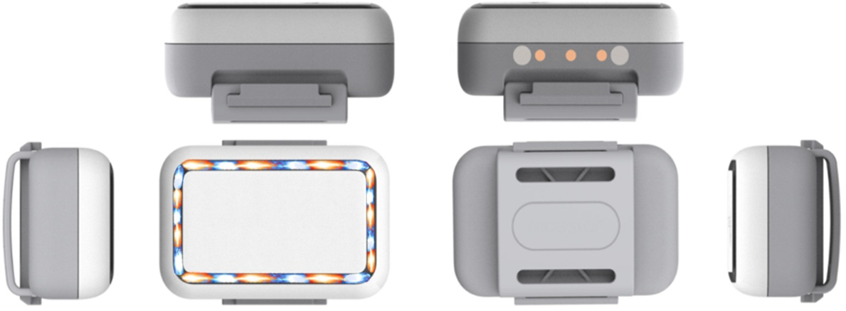

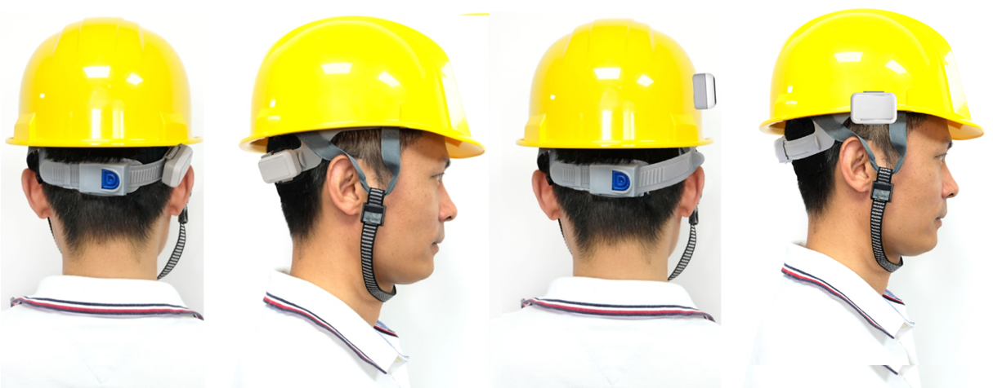

Hang on the back of the helmet; Stick to the shell of the helmet; Hang on the brim of the helmet

**Product specification**

|  |  |  |
| --- | --- | --- |
| **Category** | **Item** | **Description** |
| Appearance | Size/Weight | 44 x 27 x 18mm / 25g |
| Color | White |
| Material | PC + ABS |
| Wearing method: | adhesive to Pets Ring |
| Plarform | MCU | BLE5.1 Cortex-M4 SOC（for OTA, Broadcast / Scaning IBeacon, etc） |
| Memory | 64KB SRAM + 1MB Flash |
| G618G | Network | 4G Cat.1 |
| Band | LTE-FDD：B1/3/5/8; LTE-TDD: B34/B38/B39/B40/B41 |
| SIM Card | 5*6mm ChipSIM |
| G618L | Network | LoRaWAN or LoRa |
| Band | 433MH： Public frequency band and is suitable for most parts of the world  470~510MHz： For China Mainland，CN470  862~870MHz： For Europe，EU868  902~928MHz： For America, Australia, Asia, Korea, Japan and other regions  US915 / AU915 / AS923/ KR920 |
| G618GU  G618LU | Network | 4G( or W200PLU-LoRa/LoRaWAN)+UWB(MK8000+GPS+BLE5.1 |
| UWB Band | CH5, CH9 （UWB芯片：MK8000） |
| Cooperation model | 1. Default, it supports the UWB ranging alarm G908GU (to achieve ranging alarm) or UWB   beacon UB01 (to achieve UBeacon positioning).   1. Open MK8000-UWB SOC chip SDK, which is convenient for customers to develop MK8000   UWB air protocol and connect with third-party UWB base stations or UWB beacons. (MK8000 and device master MCU serial port communication) |
| G618M | Network | Cat M1 (eMTC) |
| Band | B1/B2/B3/B4/B5/B8/B12/B13/B18/B19/B20/B25/B26/B27/B28/B66  (Quectel BG770A Module inside) |
| SIM Card | 5*6mm ChipSIM |
| Location  And  Positioning | Location | GPS/Glonass/Galileo + Wifi + LBS + BLE |
| Satellite accuracy | 5-20 meters in an open Sky (satellite positioning at least the device can correspond to 1/4 of the unshielded sky |
| Wifi accuracy | Depending on the density of the surrounding WiFi, generally 10-50 meters |
| BLE accuracy | Depending on the deployment density of ibeacons, point, plane, and stereo positioning can be achieved  (If the beacon deployment density is 6-8 meters, the accuracy is 1-3 meters;  if it cooperates with the AOA Bluetooth gateway, it can reach the level of 1 meter) |
| Wear detection | Built-in high-precision acceleration sensor, enter ultra-low power consumption mode without moving (think not wearing it) |
| UI Interface | LED | 2 X RGB RED |
| Keypad | 1 Key in the Chager Cable. |
| Electrical Features | Battery | Li-ion Battery，600mAh / 3.7V / Charging time：2 Hours |
| Charging | Magnetic Charging Cable (standard); |
| Charger Adaptor | 5V / 1A （Optional） |
| Standby Time | Standby for more than 20 days;  normal use: more than 7-10 days (default positioning report every 10 minutes) |
| Environment  Features | Working Temp | -10°C ~ 60°C |
| storage temp. | -30°C ~ 80°C |
| Working humidity | -10% ~ 85% HR |
| Waterproof | Not waterproof (waterproof jacket in Package) |
| Functions | Electric Fence | The Platform supports circles, custom areas, and administrative areas;  the Mobile Application(IOS and Andriod Apps) supports circular fences |
| Historical Track | Support historical data query for more than 100 days |
| Alarm | SOS, Inside the fence, Outside the fence, Low Power, Power off, etc. |
| Platform | supports users to change the logo and name, hierarchical management, etc |
| Other Featues | Blind spot supplementary | Support blind spot supplementary report (positioning and health data will be saved in locations where there is no signal, waiting for a signal to be transmitted centrally) |
| G-Sensor | YES |
| Packaging | Stand Packaging | Neutral packaging：Tracker X1, Rope X1, Charger Cable X 1, User Manual X1, Platform / Apps User Manual X 1 |
| Optional | Charger Adaptor ; iBeacon OV02 / OV03 |

