**G808G：4G Cat.1+BLE+GPS, 2000mAh Battery Badge Tracker**

**Product Drscription:**

G808 Badge Tracker is waterproof and has a large battery (2000mAh). With CE certification and Ex ib IIC T4 Gb explosion-proof Certification. There are multiple versions such as 4G, LoRa, UWB, etc

1. Ultra-low power consumption, ultra-long standby

a) The system architecture is a low-power Cortex M4 main control processor + ultra-low-power LoRa module. Make sure that the system bottom

current < 0.1mA

b) Ultra-low power 4G Cat.1 bis module (Cortex M3 architecture, memory 4M+2M, small memory lower low power consumption),

Cat.1 bis module base current<10uA

c) 2000mAh capacity battery, super long standby.

2. Indoor and outdoor positioning, high-precision positioning:

a) Support GPS/Beidou + wifi + base station indoor and outdoor positioning, support Beidou No. 3

b) Reserved design: low-power 22nm process, Beidou-3, dual-frequency L1/L5 satellite positioning, to achieve high anti-interference sub-meter

satellite positioning

c) The watch has built-in Bluetooth 5.1 with low energy consumption, which supports scanning Bluetooth indoor positioning, with a positioning

accuracy of 3-5 meters. Support Bluetooth AOA high-precision positioning.

d) Support UWB high-precision positioning: Support UWB beacon mode without wiring. It also supports open UWB chip SDK for easy access to

third-party UWB systems.

e) Support UWB AoA fixed base station positioning (one base station can cover 2000 square meters)

3. Other business functions:

a) SOS one-key alarm, low power alarm, shutdown alarm, long-term inactive alarm, entry and exit fence alarm, health data exceedance, electronic

fence, historical track query and other functions

b) Positioning and health data reporting frequency settings. Support resumable transmission (in a location where there is no signal, save the data,

wait for the signal to be transmitted in a centralized manner)

c) Has a high-altitude drop algorithm.

d) 4G version support: built-in speaker and audio amplifier: support voice reminder, TTS voice broadcast.

e) 4G version support: Chinese mainland has a built-in 3-year IoT card by default. Hong Kong, Taiwan, Southeast Asia, the Middle East, Europe,

Africa, America, etc. can be shipped with cards

a) Optional: 13.56MHz RFID (M1 card or CPU card, access control, payment, etc.).

f) Optional: face device charging cabinet (40 card integrated charging cabinet - support face recognition, IC card/ID card recognition).

Available version (●: YES; ○: Default NO, can oder by Purchase)

|  |  |  |  |  |  |  |  |  |
| --- | --- | --- | --- | --- | --- | --- | --- | --- |
|  | Mode | Speaker | GPS | GPS L1/L5 | Wifi Location | BLE | RFID | 特点 |
| G808G | 4G Cat.1 | ● | ● | ○ | ● | ● | Optional | 4G Cat.1定位卡 |
| G808GU | UWB+4G | ● | ● | ○ | ● | ● | UWB+Cat.1+BLE+GPS+Wifi Location |
| G808U | UWB | ○ | ○ | **○** | ○ | ● | UWB +BLE, working with UWB AoA Gateway-U1000-C2 |
| G808L | LoRa | ○ | ● | ○ | ○ | ● | LoRaWAN(or LoRa) +GPS+BLE |
| G808LU | LoRa+UWB | ○ | ● | ○ | ○ | ● | UWB+LoRaWAN(or LoRa) +GPS+BLE |
| G808RTK | 4G Cat.1 | ● | ● | ●RTK | ● | ● | 4G Cat.1+双频北斗RTK+蓝牙BLE |
| G808GC | 4G Cat.1 | ● | ● | ○ | ● | ● | 4G Cat.1 Anti-Tamper Asset tracker |
| G808D | NBIoT | ○ | ● | ● | ● | ● | L1/L5 |

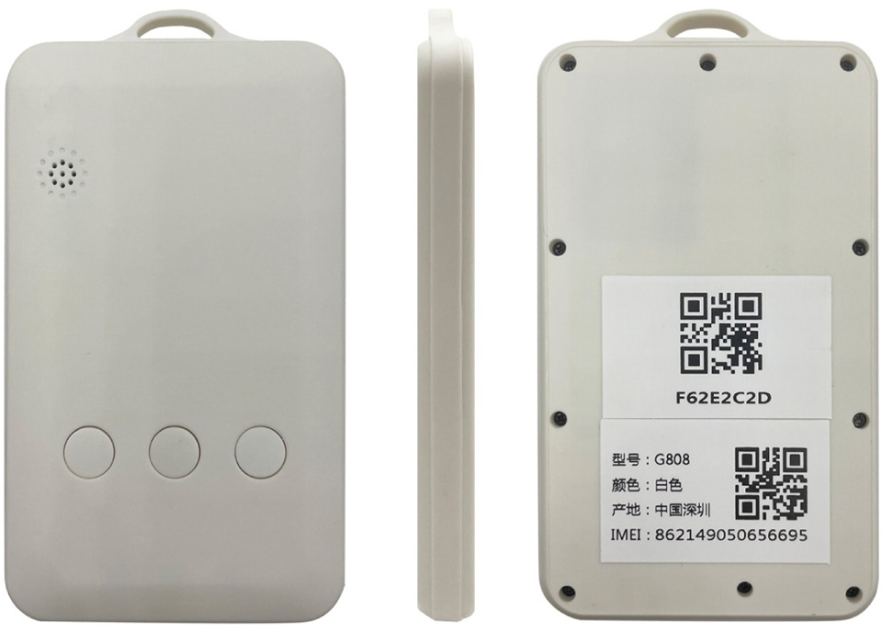 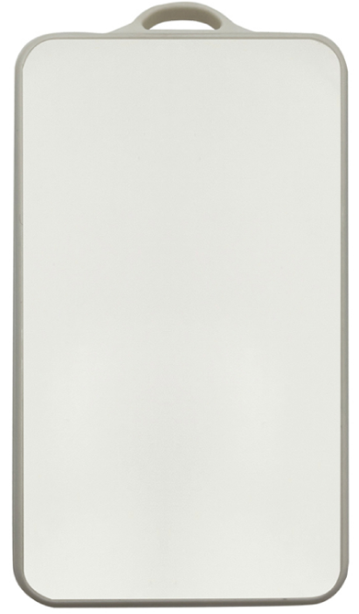

Standard: White stickers can be applied by the user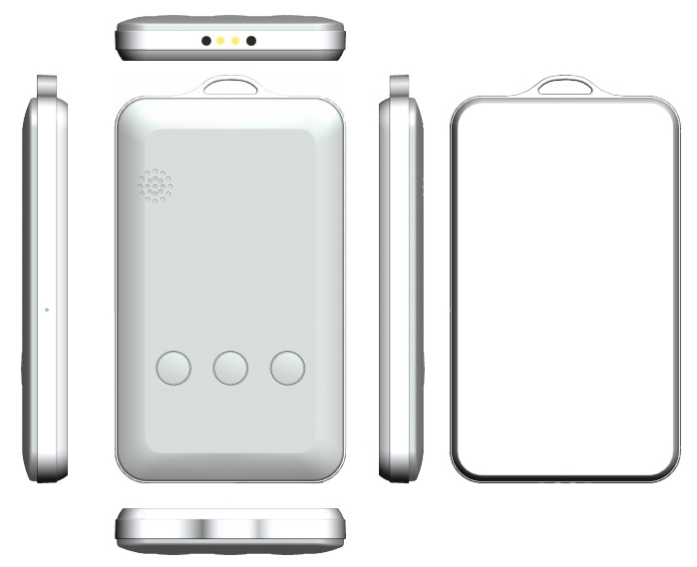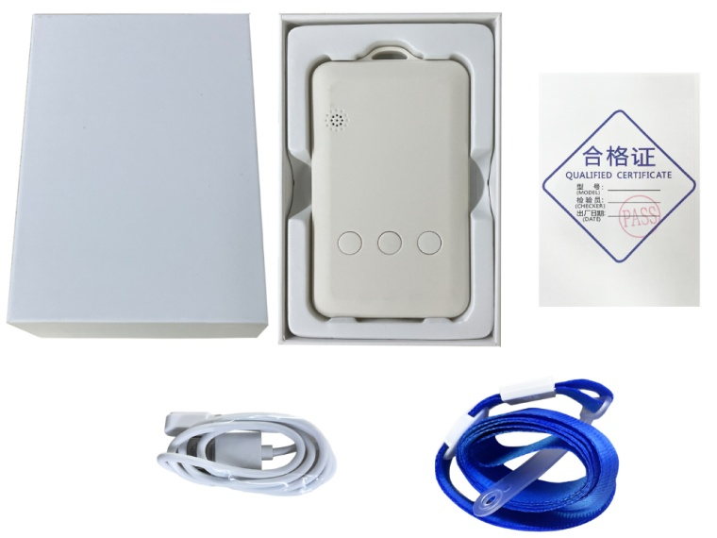

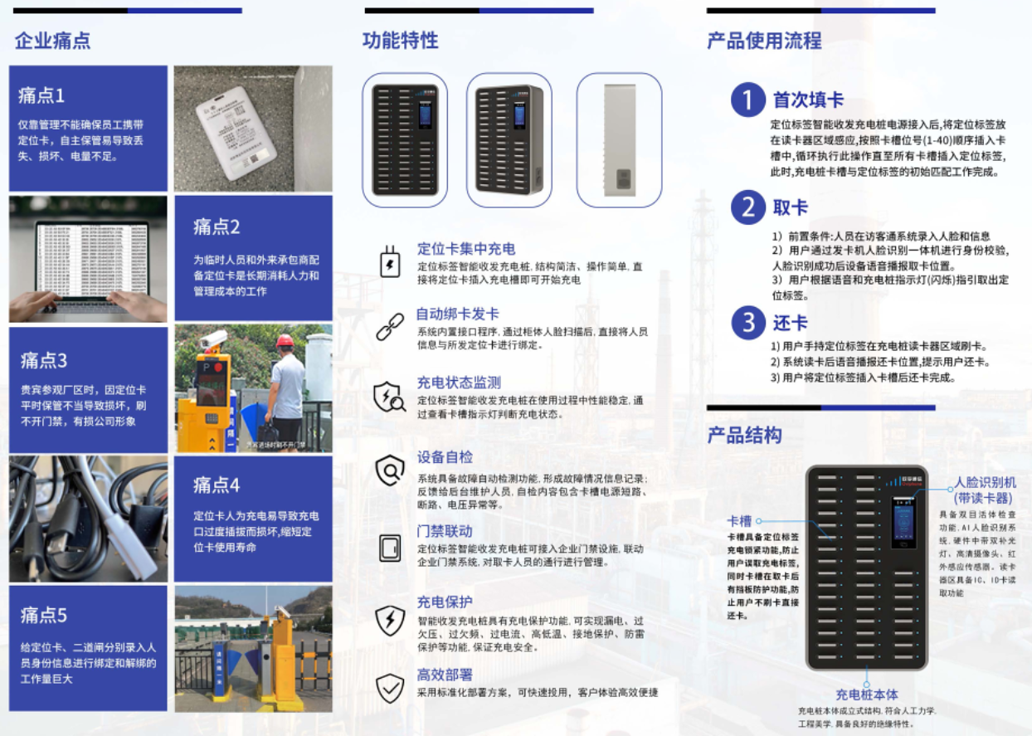

Optional: face device charging cabinet (40 card integrated charging cabinet - support face recognition, IC card/ID card recognition).

**Product specification**

|  |  |  |
| --- | --- | --- |
| **Category** | **Item** | **Description** |
| Appearance | Size/Weight | 102.8 x 61 x 12mm / 80g |
| Color | White |
| Material | PC + ABS |
| Wearing method: | Lanyard |
| Plarform | MCU | BLE5.1 Cortex-M4 SOC（for OTA, Broadcast / Scaning IBeacon, etc） |
| Memory | 64KB SRAM + 1MB Flash |
| G808G | Network | 4G Cat.1 |
| Band | LTE-FDD：B1/3/5/8; LTE-TDD: B34/B38/B39/B40/B41 |
| SIM Card | Nano SIM Inside |
| G808L | Network | LoRaWAN or LoRa |
| Band | 433MH： Public frequency band and is suitable for most parts of the world  470~510MHz： For China Mainland，CN470  862~870MHz： For Europe，EU868  902~928MHz： For America, Australia, Asia, Korea, Japan and other regions  US915 / AU915 / AS923/ KR920 |
| G808GU  G808LU | Network | 4G( or W200PLU-LoRa/LoRaWAN)+UWB(MK8000+GPS+BLE5.1 |
| UWB Band | CH5, CH9 （UWB Chipset：MK8000） |
| Cooperation model | 1. Default, it supports the UWB ranging alarm G908GU (to achieve ranging alarm) or UWB   beacon UB01 (to achieve UBeacon positioning).   1. Open MK8000-UWB SOC chip SDK, which is convenient for customers to develop MK8000   UWB air protocol and connect with third-party UWB base stations or UWB beacons. (MK8000 and device master MCU serial port communication) |
| UWB AoA  G808U  G808GU | UWB Chipset | DW1000 |
| UWB Band | CH2 |
| Cooperation model | 1. Default, it supports the UWB AoA Gateway: U1000-C2 (single UWB Gateway covers 2000 square meters) 2. Allows customers to develop their own DW1000 air protocol based on Cortex M4 SOC to connect with third-party UWB base stations or UWB beacons. |
| Location  And  Positioning | Location | GPS/Glonass/Galileo + Wifi + LBS + BLE |
| Satellite accuracy | 5-20 meters in an open Sky (satellite positioning at least the device can correspond to 1/4 of the unshielded sky |
| Wifi accuracy | Depending on the density of the surrounding WiFi, generally 10-50 meters |
| BLE accuracy | Depending on the deployment density of ibeacons, point, plane, and stereo positioning can be achieved  (If the beacon deployment density is 6-8 meters, the accuracy is 1-3 meters;  if it cooperates with the AOA Bluetooth gateway, it can reach the level of 1 meter) |
| Wear detection | Built-in high-precision acceleration sensor, enter ultra-low power consumption mode without moving (think not wearing it) |
| UI Interface | LED | 3 LED |
| Keypad | 3 Keys |
| Electrical Features | Battery | Li-ion Battery，2000mAh / 3.7V / Charging |
| Charging | Magnetic Charging Cable (standard); |
| Charger Adaptor | 5V / 1A （Optional） |
| Standby Time | Standby for more than 30 days;  normal use: more than 10 days (default positioning report every 10 minutes) |
| Environment  Features | Working Temp | -10°C ~ 60°C |
| storage temp. | -30°C ~ 80°C |
| Working humidity | -10% ~ 85% HR |
| Waterproof | IPX5 |
| Functions | Electric Fence | The Platform supports circles, custom areas, and administrative areas;  the Mobile Application(IOS and Andriod Apps) supports circular fences |
| Historical Track | Support historical data query for more than 100 days |
| Alarm | SOS, Inside the fence, Outside the fence, Low Power, Power off, etc. |
| Platform | supports users to change the logo and name, hierarchical management, etc |
| Other Featues | Blind spot supplementary | Support blind spot supplementary report (positioning and health data will be saved in locations where there is no signal, waiting for a signal to be transmitted centrally) |
| G-Sensor | YES |
| Packaging | Stand Packaging | Neutral packaging：Tracker X1, Rope X1, Charger Cable X 1, User Manual X1, Platform / Apps User Manual X 1 |
| Optional | Charger Adaptor ; iBeacon OV02 / OV03 |

