TTN debugging specification

1.TTN preparatory matters Log in to The Things Network for the first time, please register your account first (if you want to use class-c, please consider carefully. Decide whether to use the payment of the tn or chirpstack) When you log in again, when you open the page, you will jump around and click on the console to go in

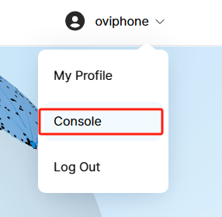

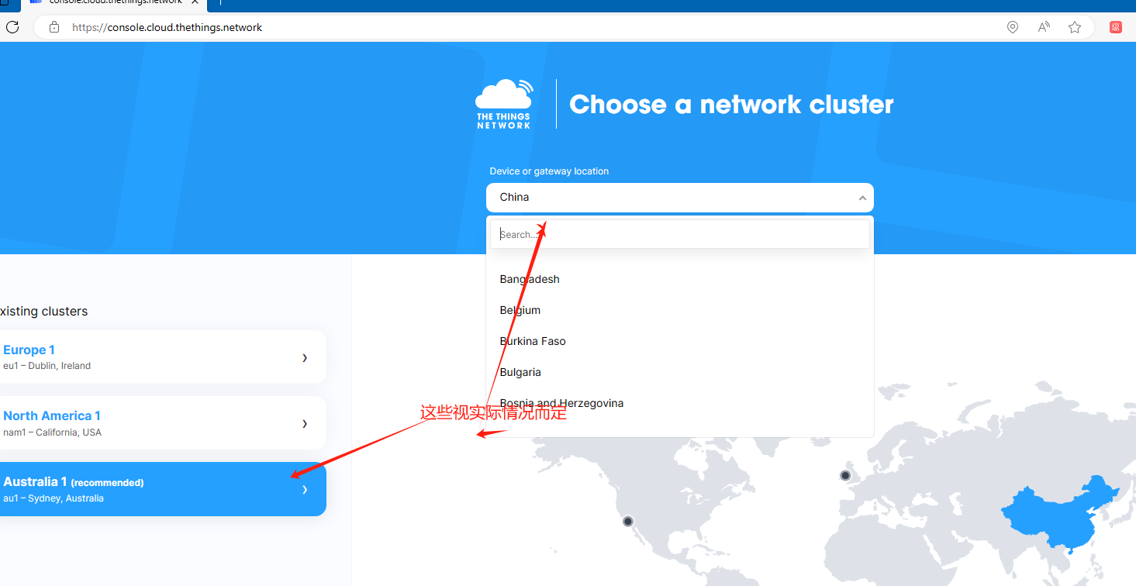

可能还要验证

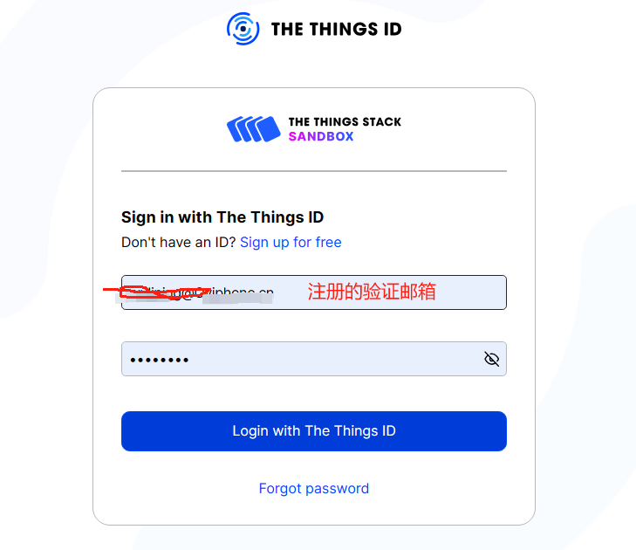

2.Open the TTN gateway, 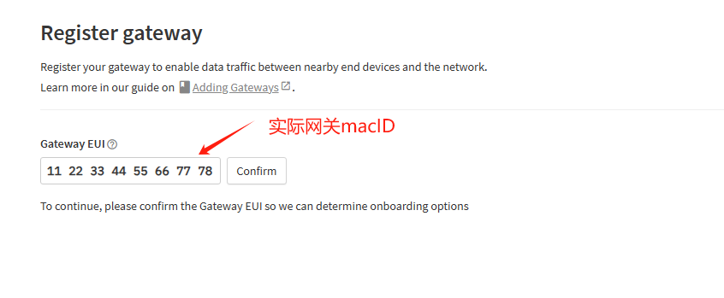

Click on the confirm in Fig

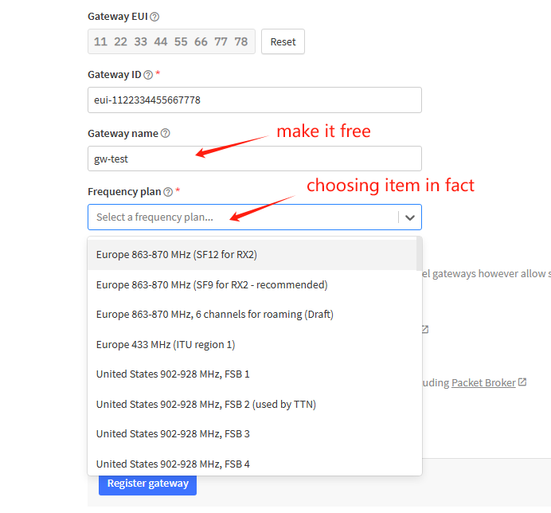

Click on register gatew to complete the registration gateway

1. 创建application名称
2. 创建Application后，点击进入后，点击+Create devices

进入该界面输入对应设备关于界面的信息，频率 大陆470 香港asia 923-925 部分产品asia 920-923；香港对应的是设备上as1 后面是as2

1. Create the application name
2. After creating Application, click to enter, click + Create devices Enter the interface to input the information about the interface, frequency mainland 470 Hong Kong asia 923-925 part product asia 920-923; Hong Kong corresponding device as1 behind as2

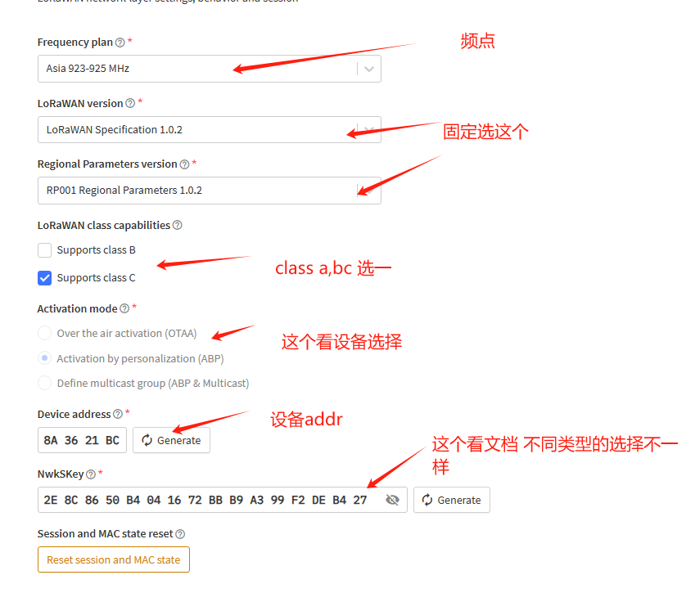

No matter otaa or abp normal to write this, nskey only abp will choose

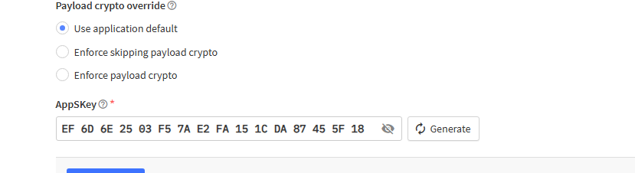

1. Click on the register after the input is complete After completing the above operation, you can view the Live DATA, view the data report, or issue the calibration time
2. If the report is not normal, you can check the comparison in the lower interface and confirm with the device side whether the ADR needs to be turned off

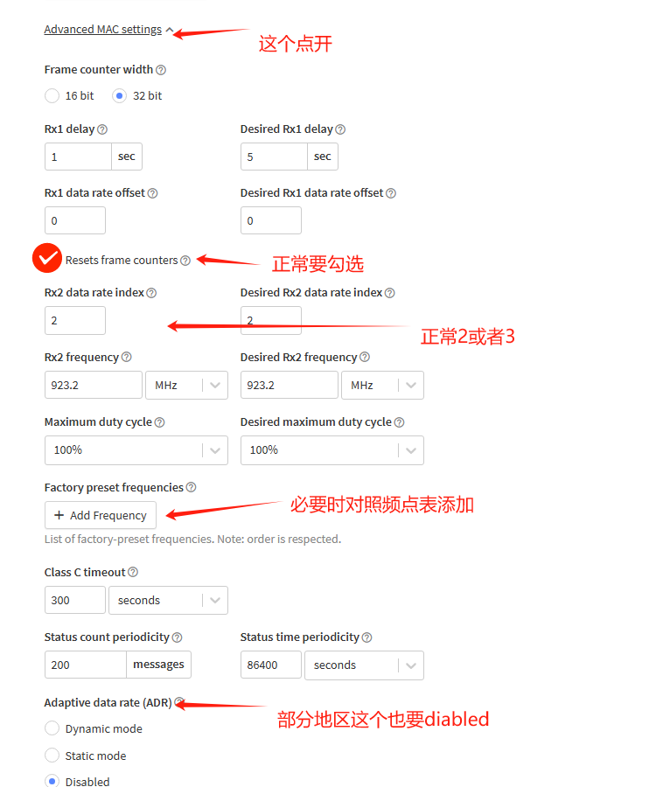

5.In addition, you can click to enter after Application, and click on the left menu Integrations-MQTT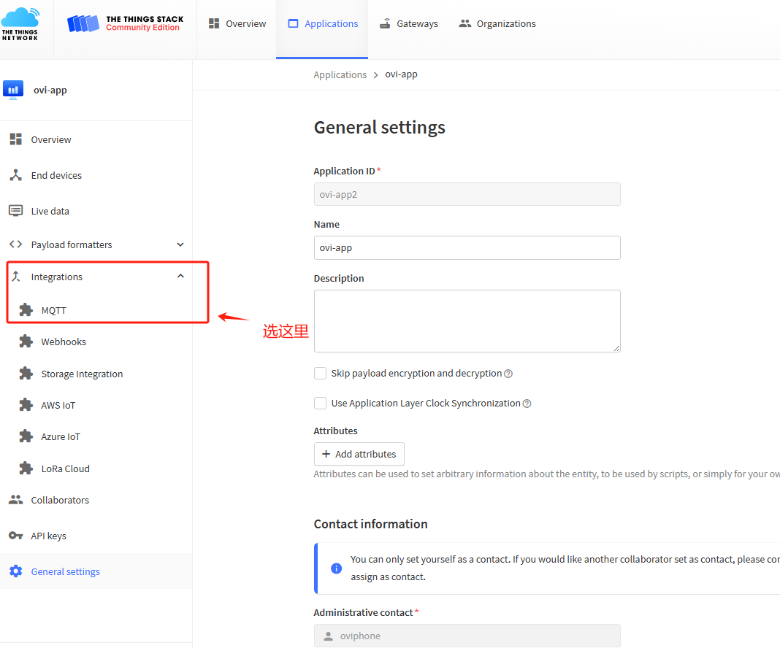

Slide down to the bottom of the page, click Generate new API key, you can record the mqtt communication with each other credentials, to the MQTT debugging tool debugging use

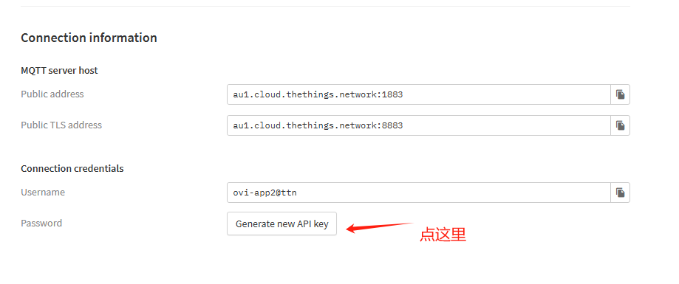

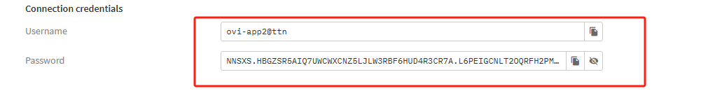

数据和自己的系统平台对接 采用mqtt 我们提供一种验证思路（工具mqttfx）

Connecting the data and its own system platform using mqtt. We provide a validation idea (tool mqttfx)

